# Introduction

In the 21st century the computer technologies have become available to a higher percentage of the world’s population. In more developed countries, especially in western countries, the personal computers and smartphones are available to mostly everyone, these technologies being part of their daily life. With such a high availability, computer technologies became an important tool of the community, especially in storage and administration of different types of data. Being widely used, different purposes and requirements appear, creating the need of different computer software to run on these machines and manipulate the data according to the requirements.

Schools are part of the institutions that deal with large amount of data. Thousands of students and employees create, submit and update new data to the school every day. This process can be problematic and time consuming. This is why lately, it became more and more common to find computer technologies implemented in schools. These technologies help in dealing with sorting, reading and storing the data. However, the use of computer technologies and computer software in schools has a very wide variety of purposes. One specific purpose of computer technologies in schools is represented by the use of online platforms required for submitting documents. This helps in saving both time and physical resources like paper. These are the reason that this type of online platform represents a valuable asset for any modern school nowadays.

## Problem statement

Considering the above mentioned information, this project is aiming on formulating and answering a problem statement that will improve the issue of computer technologies use in relation to the process of submitting homework in schools.

The problem statement is formulated as follows: “How can be designed and developed a user friendly and easy learnable platform for schools that will allow users to submit and download homework, as well as giving the functionality of booking tutors?”

An online platform is mainly created by programmers, using one or more programming languages from a wide variety of languages available on the market. The programing language is rarely a problem when developing a piece of software, even though sometimes this software or program becomes very large and complex. However, prior to beginning the development process, it is important to decide on the technologies used as well as the design and architecture.

This report is aiming to provide the technical documentation of a distributed system. This system is more exactly an online homework platform aiming to help schools ease the process of submitting homework, which is currently time and resource consuming for both students and teachers. By providing schools with such a system, we also help them implement a more sustainable policy, by reducing the amount of paper used in their process.

First of all, in what concerns the implementation of this platform in schools, the most important requirement is that all students and teachers have access to internet. This is why, for now, this homework platform is intended for schools in Denmark, where all students are guaranteed to have access to internet, that will allow the use of the platform.

Secondly, the main purpose of this online platform is to give students the ability to upload their homework as text files, on the school server. In the same time, teachers will be able to create and submit assignments on the server, from a win form client, in order to eliminate the waste of paper and time carrying this task during class time. Besides submitting assignments, teachers will also be able to download the homework submitted by the students. All the assignments and homework submitted to the database will be available for browsing in the future.

Furthermore, this platform can also be used for booking a tutor for the students. The tutors can fill in the dates there are available for tutoring, on their win form client, while the students will be able to book a tutor from the web client.

In the next chapters of this report, an in depth documentation of all the technologies used for this platform will be provided, along with considerations regarding the chosen architecture and design.

# Implementation

This chapter will only cover the implementation of a few of the functionalities of “Homework OnP”. These functionalities have been chosen according to the business value of their respective user story.

## Login functionality

First of all it has to be mentioned that the login functionality has not been implemented directly from the template, but instead created manually.

Keeping in mind that this platform uses a WCF service, there is a set of methods and calls made from the client to the service and through all the layers in the service. Also it is important to mention that the login functionality is implemented on two different clients, a web client and a win form client. Each of these clients works with a different type of objects. As such, only Child objects are able to log in and use the web client interface, while the win form allows only Teacher objects to log in. However, a single Login method is used for both cases.

The username and password are passed from the client to the service calling the Login(string username, string password) method. At this point, the password is already hashed by calling a method from the service and returning the hashed value of the UserPasswordTB input.

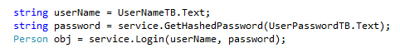

Figure 1 - WebClient hashing password

The actual hashing of the password happens in the PassHash class from the BLL. In this class there is a method that takes a string parameter and returns the hashed value of this string. The hashing is made using the SHA256CryptoServiceProvider class. A previous version of the platform was using the GetHashCode() method, available for a string object. This has been replaced due to its lack of security.

Following, the service calls the UserCtrl in the Business Logic Layer (BLL) where a Person object is built with the two parameters. This object is further passed to the Data Access Layer (DAL) which queries the database for a user with the specified username and password. If there is any match, a Child or Teacher object is build, according to the user type value, and it is returned through layers all the way to the client, as an Person object.

After returning the object from the database, each client has the duty of checking wheatear the returned object is corresponding to the type allowed in the client, respectively Teacher for the win form client, and Child for the web client. This takes place using the typeOf() method. In this way the platform ensures that no Child will be able to log in on a win form client, and vice versa.

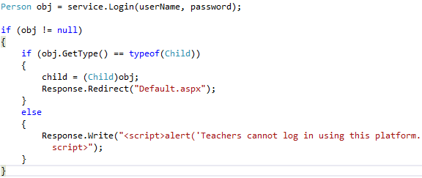

Figure 2 - WebClient - object type check

A previous version of the login functionality included two login methods in the service, one for each client. An Object type was returned from the lower layers, and it was casted in each login method, to the corresponding type, before returning it to the client. In this way the service was carrying all the work in connection to the login functionality.

## Submit homework functionality

It represents the main functionality of this online platform, even though the login functionality has been covered first. This is because users were required to be logged in before being able to submit their homework.

Similarly to the previous functionality, the submit homework process goes through the same layers. Even though the upload of the document happens on the client side, a Homework object is created in the BLL and is added to the database, containing the title, exercise, date, the disk name of the uploaded document, and the assignment for which it was submitted.

In this case, the SubmitHomework method in DAL returns an integer that specifies if any row has been changed in the database. This integer is returned all the way to the web client, and according to it a message is displayed to the user confirming of denying the upload of the document.

An important thing to explain here is how the assignmentId is used. In order to create an assignment, the platform offers a combo box where the user can select the assignment he/she wishes to upload homework for. Even though a list of Assignment objects is returned from the service, the combo box is populated with an array of strings formed by concatenating the assignmentId with the name of the assignment.

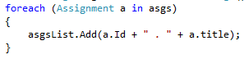 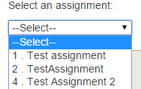

Figure 3 - Populating list of strings with assignment id and name

Having the combo box populated with strings, the selected index is used to extract the Assignment object from the list of assignments retrieved earlier from the service. This object is then used on writing the title and exercise of the assignment in a text box, so that the user can see the exercise he selected.

However, the assignment id sent to the service for creating homework object is extracted differently. The selected value from the combo box is broken into an array of string using the Split(‘ ‘) method. In this way considering Figure 3, the first string will always be the id of the assignment.



Figure 4 - Retrieving assignmentId from combo box

## Create assignment functionality

This method can only be accessed from the win form client, the functionality being available only for the teachers. The assignment is created in the same way as the homework, passing all the parameters from the win form client (title, date, deadline, exercise and the teacher id), all the way to the AssignmentCtrl in BLL, where an Assignment object is built, and in DAL its information is stored in the database.

A set of checks have been created in the win form client, in order to make sure that the user does not create an invalid assignment. In the figure below it can be seen how first the title and exercise fields are checked to make sure they are not null. If these checks pass, the dates are also checked to make sure the deadline is not set before the starting date of the assignment, fact which would make the assignment invalid. Only if all these checks pass, the values will be forwarded to the service, calling the “CreateAssignment” method. The returned integer will be checked and according to it, a message will be displayed to the user.

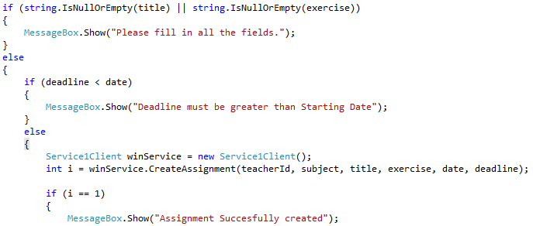

Figure 5 – Create assignment checks in win form client

## Book tutor functionality